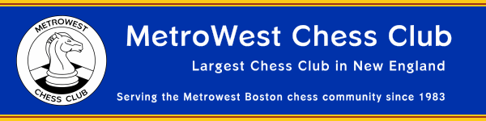

Featured:
- USATE
- Club and Class Championships
March 2012

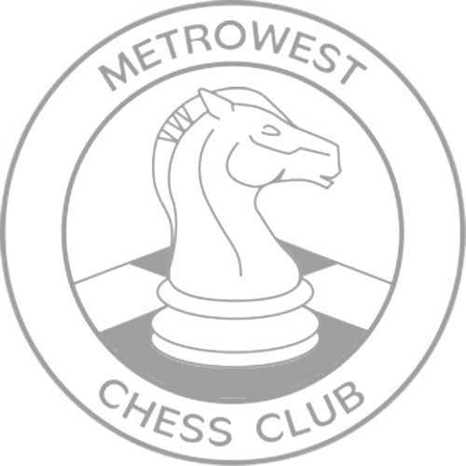

Social Media
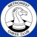
The MetroWest CC social media page has been updated. The biggest change is that Facebook is changing how groups are handled, so MetroWest CC has a new Facebook page. The old MetroWest CC Group will be retired.
The new MetroWest CC Facebook page is here:
https://www.facebook.com/pages/MetroWest-Chess-Club/164738746955775
Please visit our MetroWest CC Facebook page and “Like” us! Also visit MetroWest CC social media page: http://www.metrowestchess.org/Community/Social_Media/Top_Social_media.htm
Weekly Group Lessons
MetroWest CC is taking steps to strengthen the Weekly Group Lesson program. Plamen Krastev is working with candidate instructors to find a balance to achieve a few high quality lessons per month. This comes after Felix Yang left for school earlier last year. Please check this newsletter for more info, and our calendar for scheduled lessons. The last lesson was “Conjuring up Counterplay against Queen Pawn Openings”, delivered by David Harris on Jan 24.
Game Commentary
After a brief gap, we are back on track publishing games of top boards. Please check the MetroWest CC MetroWest CC Facebook page, Twitter feeds, and news blog for announcements of newly posted games. Please check out the MetroWest CC social media page (above) for more details.
Event Participation Awards
We plan on resuming the awarding of Event Participation Awards prior to rounds starting during select rounds in 2012. We will announce which rounds the prior month.
Natick Senior Center
Announcement from the Senior Center:
During the construction of Natick’s new community senior center, the Senior Center and the club is temporarily in a new location for about 14 to 18 months
Our temporary quarters are at the former East School at 90 Oak Street, Natick:
It is on the westbound side of Route 9 opposite Scrub-a-Dub carwash. The entrance is on Oak Street. It was most recently occupied by Westgate Christian Academy—some people may have known where that was. See map below.
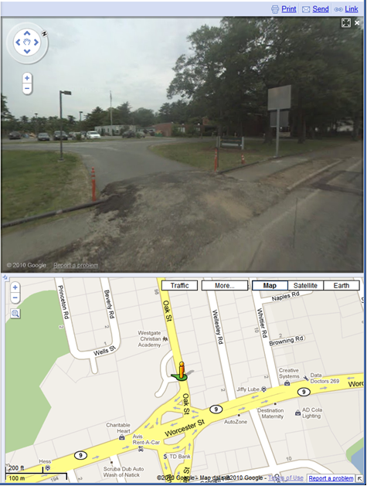


USATE
By Matt Phelps
The USATE team "The Shmelov Sox" featuring MCC members Denys Shmelov, Derek Slater, and Matt Phelps, along with WGM Anya Corke, finished with 5.0 out of 6.0 points and won the “Best Massachusetts Team” prize. Many other MCC regulars competed including GM Arthur Bisguier, IM David Vigorito, IM James Rizzitano, Vadim Martirosov, Ilya Krasik, Ben Goldberg, Dr. Edward Epp, Mark Fins, Bill Michael, David Plotkin, and probably more.
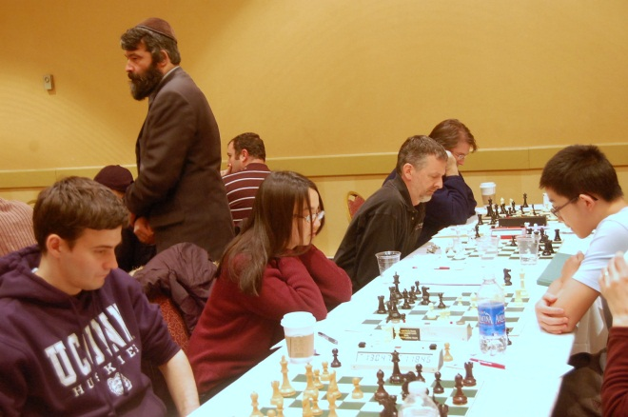
Photo of “The Shmelov Sox”, by Robert Oresick, with GM Leonid Yudasin in the background.
MetroWest CC Club and Class Championships
By Matt Phelps
Invitations for the 2012 MCC Club and Class Championships will go out later this month (March 2012). Players quialify for invitations based on their 2011 performance at MCC events. The two six player round robin tournaments will take place in May 2012. See http://www.metrowestchess.org/Compete/Championships/2012/2012_Championship_Qualification_Points_List.pdf for the final points standings.
Eastern Class 2012
By Mark Kaprielian
Pictures from the Eastern Class tournament will be posted shortly, to the pictures page.

Last Tournament
“MCC Groundhog Day Swiss”
Congratulations to the Winners!
OPEN | Ilya Krasik | 3.5 / 4.0
U2000 | Nikita Konovalchuk | 3.5 / 4.0
U1700 | Walter Champion, Robert Kaminsky | 3.5 / 4.0
U1400 | Tom Iversen | 3.5 / 4.0

Perfect Scores

No perfect scores. Who will it be next month?
Photos From Around the Club


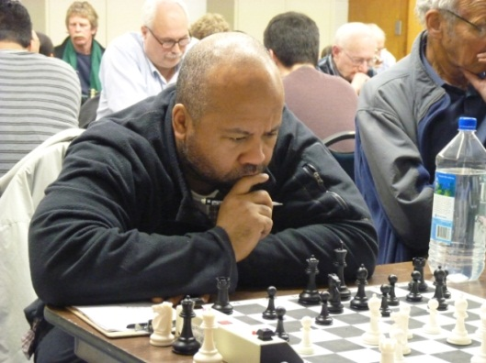
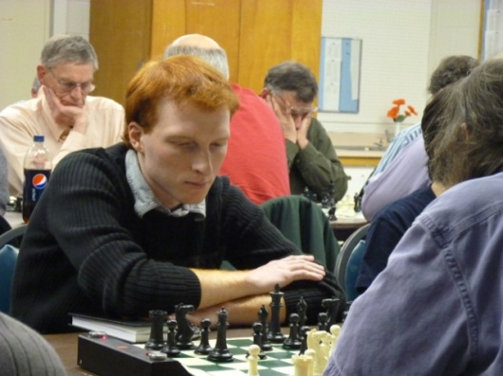
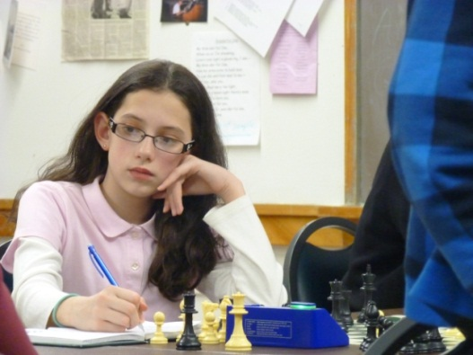

Next Tournament
“MCC April Fools Swiss”
When | Tuesdays at 7:30 pm  April 3, 10, 17, 24 2012
Format | 4 - SS 40/90, SD/30
Sections | Open, U2000, U1700, U1400  Open section FIDE rated
Prize Fund | $ 630 100% Guaranteed
Entry Fee | Club Masters Free  MCC Members $20  Non-members $25
Prizes | Open $ 120 - 80 - 60  U2000 $ 80 - 60 - 40  U1700 $ 60 - 40 - 20  U1400 $ 40 - 20 - 10
Championship Points | Open 64 - 40 - 24 - 16  U2000 32 - 20 - 12  U1700 16 - 10 - 6  - 25% bonus for winning all games  - 15 point bonus for upset win/draw over an 1800+ player and 300/600 rating diff
Forfeit Rule | Players may be re-paired after 30 min
Additional Events | Checkout the Possible Events of Interest link on the Club homepage for other events in the area

The current championship qualification standings are available online at:
http://www.metrowestchess.org/Compete/Championships/2012/2012_Championship_Qualification_Points_List.pdf


Weekly Group Lessons
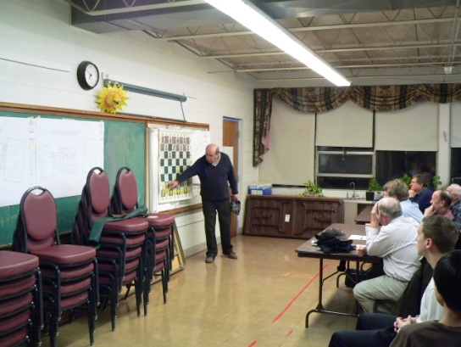
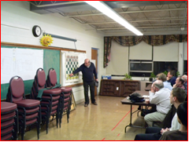
Check calendar on homepage for availability.
Bookseller
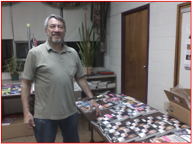
Emanuel Rasin of “Books from Europe. Check calendar on homepage for availability.

