

Featured:
- Club and Class Championships
- Regional (non-MCC) event -- 2012 Spring Girls Chess Tournament

March 2012

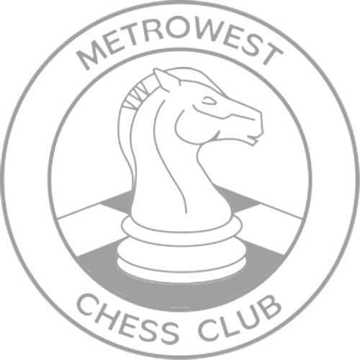

Social Media

The MetroWest CC social media page has been updated. The biggest change is that Facebook is changing how groups are handled, so MetroWest CC has a new Facebook page. The old MetroWest CC Group will be retired.
The new MetroWest CC Facebook page is here:
https://www.facebook.com/pages/MetroWest-Chess-Club/164738746955775
Please visit our MetroWest CC Facebook page and “Like” us! Also visit MetroWest CC social media page: http://www.metrowestchess.org/Community/Social_Media/Top_Social_media.htm
Weekly Group Lessons
MetroWest CC is taking steps to strengthen the Weekly Group Lesson program. Plamen Krastev is working with candidate instructors to find a balance to achieve a few high quality lessons per month. This comes after Felix Yang left for school earlier last year. Please check this newsletter for more info, and our calendar for scheduled lessons. The last lesson was “Conjuring up Counterplay against Queen Pawn Openings”, delivered by David Harris on Jan 24.
Game Commentary
After a brief gap, we are back on track publishing games of top boards. Please check the MetroWest CC MetroWest CC Facebook page, Twitter feeds, and news blog for announcements of newly posted games. Please check out the MetroWest CC social media page (above) for more details.
Event Participation Awards
We plan on resuming the awarding of Event Participation Awards prior to rounds starting during select rounds in 2012. We will announce which rounds the prior month.
Natick Senior Center
Announcement from the Senior Center:
During the construction of Natick’s new community senior center, the Senior Center and the club is temporarily in a new location for about 14 to 18 months
Our temporary quarters are at the former East School at 90 Oak Street, Natick:
It is on the westbound side of Route 9 opposite Scrub-a-Dub carwash. The entrance is on Oak Street. It was most recently occupied by Westgate Christian Academy—some people may have known where that was. See map below.
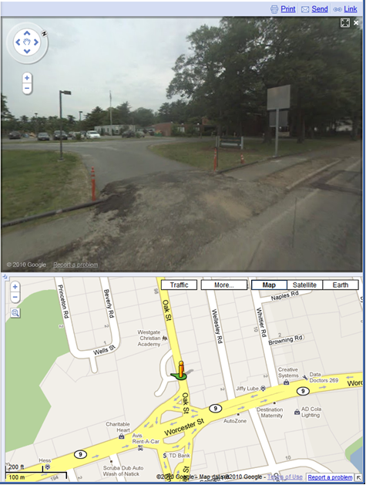


Regional (non-MCC) event -- 2012 Spring Girls Chess Tournament
By Irina Dronova
We are planning to run a chess tournament for girls on May 6th. We encourage any girl players at the MetroWest Chess Club to enter and play.
The 2012 Spring Girls Chess Tournament
Scholastic K-12
- When: May 6th, 2012 – Sunday 10 a.m.
- Prizes: 1st, 2nd, 3rd place trophies
- Medals: To all girls, who score three points
- Where: Embassy Suites, 123 Boston Post Road West, Marlborough, MA 01752 Ph. 508-460-5900
- What: 4-round USCF rated, Game 40
- Sections: Open; Novice - Under 700
- Entry Fee: $15 Pre-registration or $20 at door.
- Registration: May 6th: 9:15-9:45 a.m.
- Byes: One half-point available in rounds 1-4 per request; limit 1.
- USCF: Membership required, please bring game set and chess clock.
- Questions: (508)-735-6425(cell) Irina Dronova or e-mail: ivdronova@yahoo.com
Entry Form, last two pages of this newsletter

MetroWest CC Club and Class Championships
By Matt Phelps
Invitation letters have been sent out and players have until April 17th to respond. After the lineups are set, a random drawing will be held at the club to determine seedings. The pairings for the entire tournament will then be posted.
See http://www.metrowestchess.org/Compete/Championships/2012/2012_Championship_Qualification_Points_List.pdf for the final points standings.
Eastern Class 2012
By Mark Kaprielian
Pictures from the Eastern Class tournament are nowposted to the pictures page.

Last Tournament
“MCC Vernal Equinox Swiss”
Congratulations to the Winners!
OPEN | Igor Foygel, Jonathan Yedidia | 3.5 / 4.0
U2000 | Yuriy Zhaurov | 4.0 / 4.0
U1700 | Walter Champion, Robert Kaminsky | 3.5 / 4.0
U1400 | David J Flanagan | 4.0 / 4.0

Perfect Scores
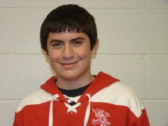
Yuriy Zhaurov David J Flanagan
Photos From Around the Club
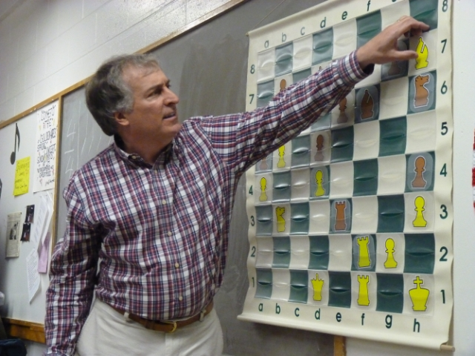
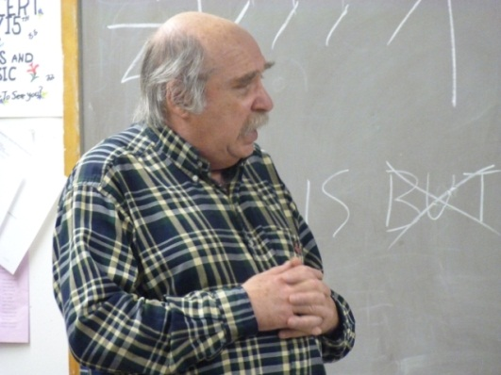

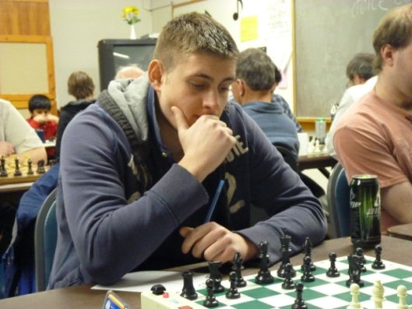


Next Tournament
“MCC April Fools Swiss”
When | Tuesdays at 7:30 pm  April 3, 10, 17, 24 2012
Format | 4 - SS 40/90, SD/30
Sections | Open, U2000, U1700, U1400
Prize Fund | $ 630 100% Guaranteed
Entry Fee | Club Masters Free  MCC Members $20  Non-members $25
Prizes | Open $ 120 - 80 - 60  U2000 $ 80 - 60 - 40  U1700 $ 60 - 40 - 20  U1400 $ 40 - 20 - 10
Championship Points | Open 64 - 40 - 24 - 16  U2000 32 - 20 - 12  U1700 16 - 10 - 6  - 25% bonus for winning all games  - 15 point bonus for upset win/draw over an 1800+ player and 300/600 rating diff
Forfeit Rule | Players may be re-paired after 30 min
Additional Events | Checkout the Possible Events of Interest link on the Club homepage for other events in the area

The current championship qualification standings are available online at:
http://www.metrowestchess.org/Compete/Championships/2012/2012_Championship_Qualification_Points_List.pdf


Weekly Group Lessons
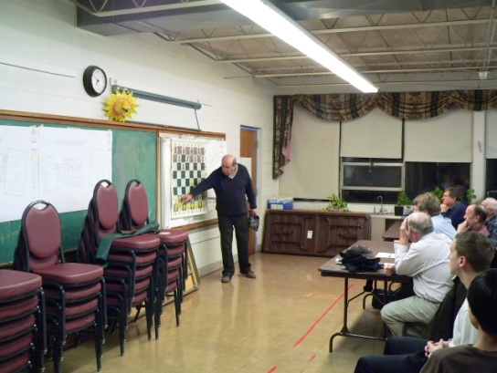
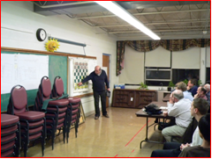
Check calendar on homepage for availability.
Bookseller
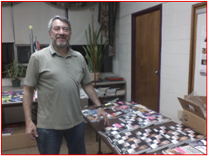
Emanuel Rasin of “Books from Europe. Check calendar on homepage for availability.
************************************************************************************


The 2012 Spring Girls Chess Tournament

Scholastic K-12
May 6th, 2012 – Sunday 10 a.m.
****************************
Prizes: 1st, 2nd, 3rd places - trophies

Medals to all girls, who scores three points

Where: Embassy Suites, 123 Boston Post Road West, Marlborough, MA 01752 Ph. 508-460-5900
I-495 North, Exit 24B. Merge into US-20W toward Northborough.
Continue to follow US-20W. Destination will be on the right. Plenty of parking in the back.

What: 4-round USCF rated, Game 40 Sections: Open; Novice - Under 700
Entry Fee: $15 pre registration or $20 at door. Registration: May 6th: 9:15-9:45 a.m.
- One half-point available in rounds 1-4 per request; limit 1.
- USCF membership required, please bring game set and chess clock.
Questions: (508)-735-6425(cell) Irina Dronova or e-mail: ivdronova@yahoo.com

Please bring this entire form to save time during registration. Thank you!

The 2012 Spring Girls Chess Tournament

Name: ____________________________________________________ USCF#:____________________

Address: _________________________________________________ Rating: ____________________

E-mail Address: ___________________________________________ Phone: ____________________

Need USCF membership? Section:____________________
Print $30 Young Adult (24 or Under), Online $23
Print $25 Youth (15 or Under), Online $19
Print $21 Scholastic (12 or Under), Online $14 USCF: $______________

Please mail your checks and forms to: Irina Dronova Entry Fee: $____________

72 Vassar Street, Worcester, MA 01602

Total: $____________

*****************************************************************************************

